# Lab 05: Getting started with R and building our R applications

Muhammad Ali(128469)

**GITHUB** : https://github.com/ali28729/SE312_Labs/tree/master/Lab05

BESE6B

1. Use the mtcars data set to plot different graphs in order to convince a buyer which is the best car to buy. Assume some kind of criteria that the car is interested in e.g. Young buyer with interest in speed, or an executive thinking of buying a luxury sedan etc.

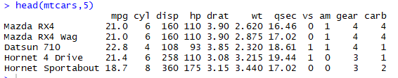

**Plotting between Mpg and hp**

> plot(mtcars$wt, mtcars$mpg, main="Scatterplot Example", xlab="Car Weight ", ylab="Miles Per Gallon - MPG ")

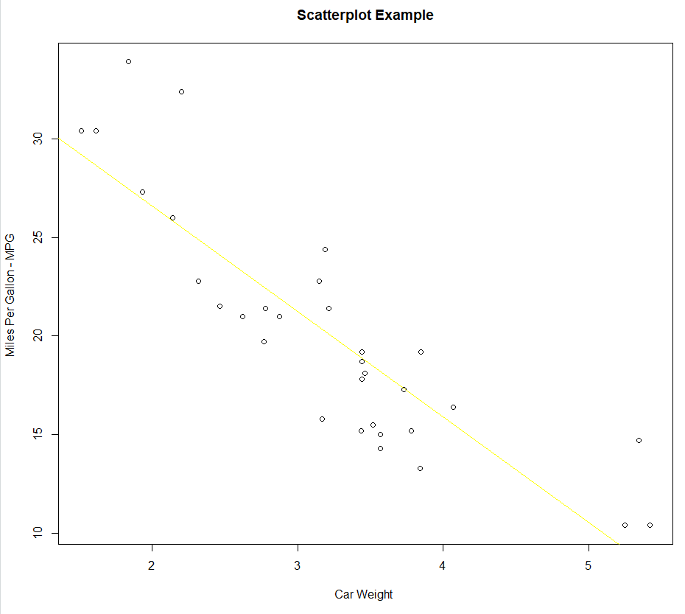

> abline(lm(mtcars$mpg~mtcars$wt), col="yellow")

**Plotting between qsec and hp:**

|  |
| --- |
| > plot(x = mtcars$hp, y = mtcars$qsec) |
|  |
| |  | | --- | |  | |

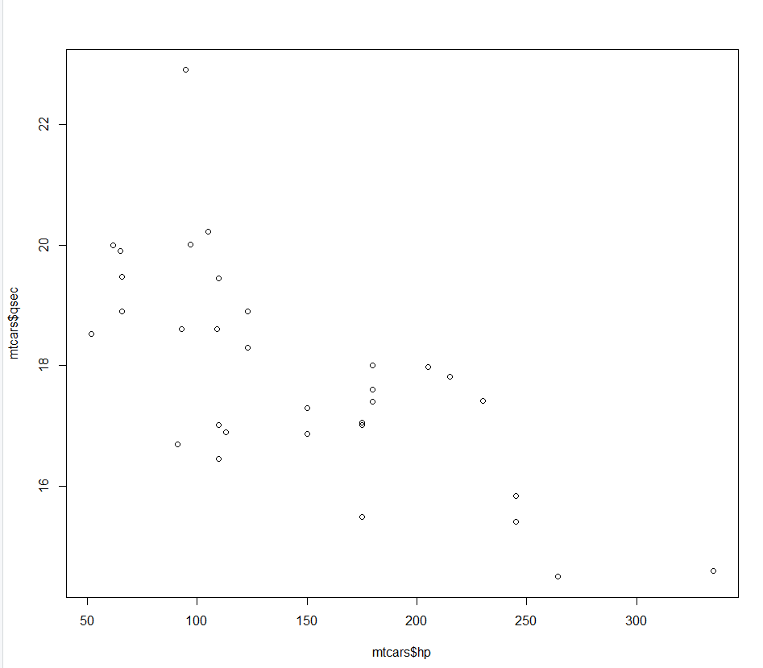

**Plotting between 1 and 5 all attributes through combined scatter plot**

|  |
| --- |
| > plot(mtcars[,1:5]) |
|  |
| |  | | --- | |  | |

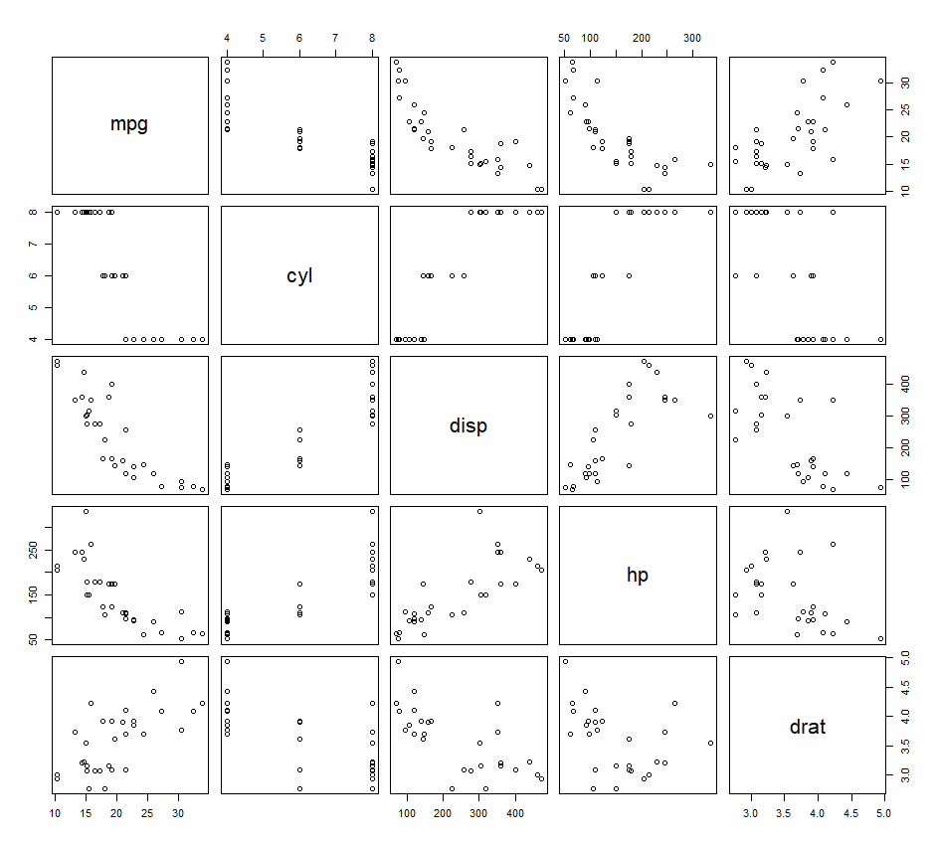

**Plotting b/w 2 and 5 all attributes by**

**combined scatter plot**

> plot(mtcars[,2:5])

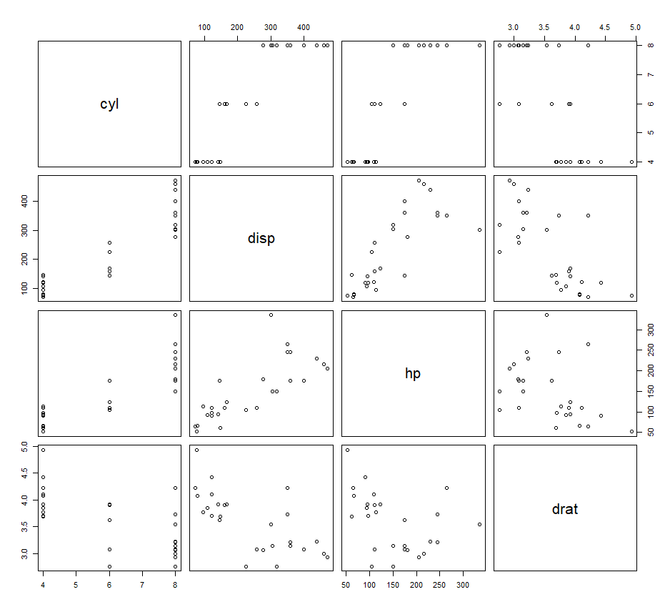

**TASK 6**

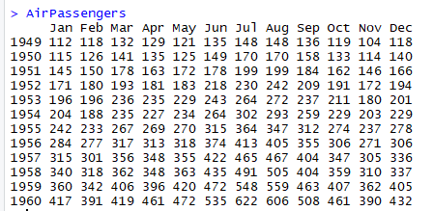

* **Read ninto table by:**

blob<-read.table(h=T,text="Jan Feb Mar Apr May Jun Jul Aug Sep Oct Nov Dec

==1949 112 118 132 129 121 135 148 148 136 119 104 118

1950 115 126 141 135 125 149 170 170 158 133 114 140

1951 145 150 178 163 172 178 199 199 184 162 146 166

1952 171 180 193 181 183 218 230 242 209 191 172 194

1953 196 196 236 235 229 243 264 272 237 211 180 201

1954 204 188 235 227 234 264 302 293 259 229 203 229

1955 242 233 267 269 270 315 364 347 312 274 237 278

1956 284 277 317 313 318 374 413 405 355 306 271 306

1957 315 301 356 348 355 422 465 467 404 347 305 336

1958 340 318 362 348 363 435 491 505 404 359 310 337

1959 360 342 406 396 420 472 548 559 463 407 362 405

1960 417 391 419 461 472 535 622 606 508 461 390 432")

* **Find the most profitable year in the 12 years**

JULY

>colSums(blob)

* **Plot the company’s growth over the 12 year period.**

1960

>rowSums(blob)

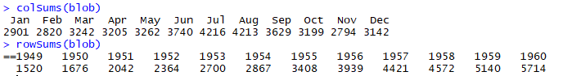

* **Plot the company’s growth over the 12 year period.**

>plot(AirPassengers)

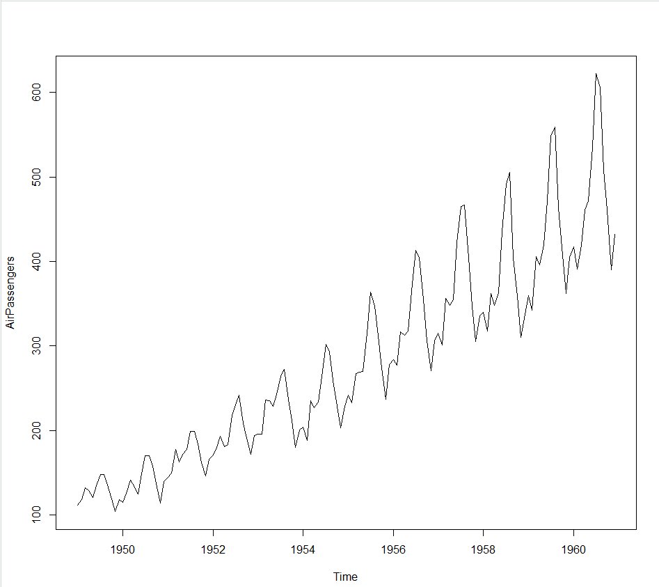

**TASK 7**

bleb= c(8000,8800,9680,10648,11712.8,12884.08,14172.5,15589.75,17148.73,18863.6,18863.6,20749.96)

blobber<-bleb*blob

* **calculate the highest revenue month in the 12 years’ data**

JULY: 66115803

colSums(blobber)

* **Calculate the highest revenue year in the 12 years of operations**

1960 : 118565271

rowSums(blobber)

* **Calculate the total revenue of the 12 years**

12 years :627701445

Blob1<-colSums(blobber)

sum(Blob1)

627701445

sum(rowSums(blobber))

627701445

